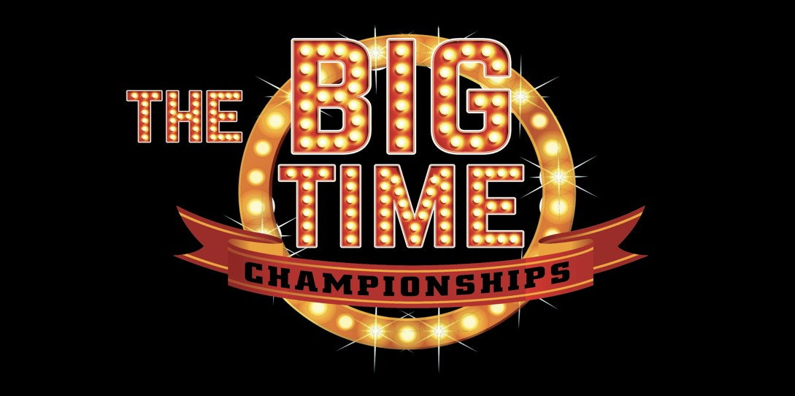

BIG TIME RULES
- All pre-entries must be postmarked by the deadline. Late entries must be paid in cash, and a $100 late fee per day will be charged for the open. There will be a $50 late fee for youth. Late entries will run at the end of the draw.
- All contestants must compete in Dress code. Dress code is long sleeve shirt and cowboy hat/helmet. Failure to do so will result in a no time.
- The Big Time encourages all contestants to check the draw for position postings.
- Barrels will be set OFF the markers for the time onlys
- The Big Time will tractor rake after every 5 entries. Big drag every 50.
- The Arena will be closed at the conclusion of each race. No one is allowed in to ride or work horses after the race.
- Turnouts will not change the draw. All positions will be drawn.
- All Big Time contestants and their family members are expected to display good sportsmanship at all times. No level of abuse toward any animal at The Big Time events will be allowed. Foul language, misconduct or abusive comments spoken to any Contestant, Spectator, Big Time staff member, or Big Time Arena Personnel will result in immediate contestant disqualification and no refund of entry fees. Contestants are also responsible for traveling companions and family members.
- Contestants shall identify themselves before their name is called by the announcer, to the Gate Man to be located next to the alley way going in to the arena. Failure to do so will result in disqualification. Contestants name will be called by the Announcer three times, if the contestant is not in the arena by the third call they will be disqualified. Only one horse may be in the alleyway at any time.
- An electric eye will be used for all runs. Should the timer fail to function; a rerun will be given after the event or at the producer’s discretion.
- There will be no reruns given if a horse falls.
- There will be no pulling up a horse to try to place in a certain division.
- Knocking over a barrel will result in a no time. A “no time” will also be given if a barrel is knocked over and it sets up again on either end. Touching a barrel, including trying to keep it from falling, is permitted without penalty.
- If any contestant’s times or point totals are tied, the prize money will be split equally. A draw of the card will determine the winner. The highest card wins the prizes or the fastest time.
- All fees must be paid in US currency.
- Returned check fee is $30.00
- All dogs must be on leashes at all times. No dogs in the holding areas
- If a barrel is moved off its marker during competition, the barrel must be reset prior to the next competitor’s run.
- A horse may not change draw positions. Only one horse may be in the arena or alleyway during the Big Time competition.
- A No Time will be given to a contestant for the following reasons; if the contestant circles their horse after entering the arena (Defintion of the arena is past the plane of the alley.) If the contestant misses the barrel pattern. If the contestant runs out of turn. It is the contestant’s responsibility to know their draw position.
- There shall be no selling of any type of merchandise or professional service on the arena grounds, in stalls, or at trailers without a vendor contract with the Big Time.
- Vet Releases and medical releases for draw outs will be accepted up until March 5th. Minus a processing fee of $100
- Horse substitutions are accepted for the draw only up until March 5th. After March 5th $25 substitute fee will be charged. If you vet out or medical out of the race the entry fees will be returned, less the processing fee of $100.
- After March 5th you may sell your spot with a $25 transfer fee or roll your entry to another Big Time event.
- The $100 late charge is per person. Late entries will be accepted at all races Credit Card or Cash only entries. A 3% finance charge will be added to all credit card payments.
- The rotation payouts will be an Open 4D; .5,.5, 1 second splits. Rotations will be split in half by total number of runners each day.
- The Daily payouts will be an Open 5D; .5, .5, .5, .5 second splits
- The overall Big Time payouts will be an Open 5D; .5, .5, .5, .5 second splits
- The 2D futurity sidepot will be for 4 & 5 year olds. Full second splits
- The 2D derby sidepot will be for 6 & 7 year olds. Half second splits
- All sidepots will be 80% payback.
- The Ledge Gun age is 50 & over on the day of the race.
- The Young Gun age is 18 & under on the day of the race.
- The producers of the race will settle any and all disputes. The producer’s decision is final.
- The Big Time reserves the right to refuse entry for any reason.
- If you have tipped barrel insurance you must tip a barrel to use. You cannot use if you have a broken pattern. You must tell the office that you would like to use before the buyback round. You must purchase the tipped barrel insurance before your run.
- If tipped barrel insurance is used, the new time counts for the Daily and the Big Time payout, but not the rotation or side pot payouts.
- You may buyback for $1,500. You can buyback for any reasons.
- Anyone buying back or using tipped barrel insurance, must inform the office by noon each day for the open and 3 pm each day for the youth.

